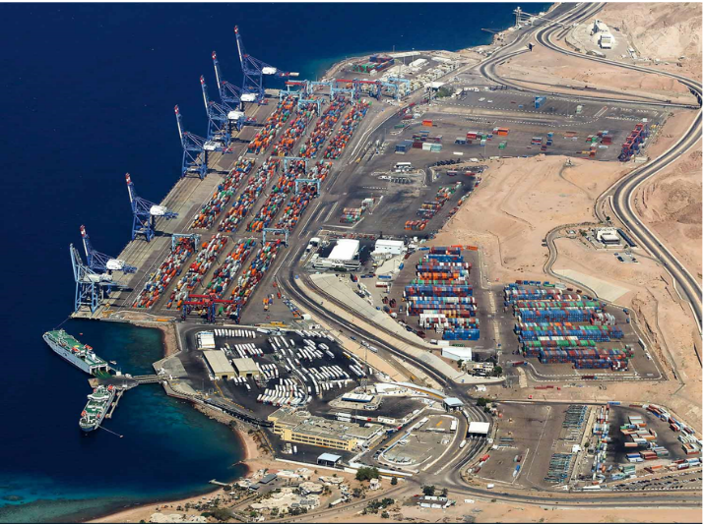

Line Registration Form

I have read and agree to the Terminal [Terms of Business](https://www.apmterminals.com/en/aqaba/practical-information/tariffs)

Date:

Agent:

Line Name:

Line ID:

Agent ID:

Agent Name:

Requirements:

* Nomination letter
* Fill ACT communication matrix.
* License from Jordan Maritime Commission

Agent Signature / Stamp: